AWS VPC (Virtual Private Cloud) is a logically isolated virtual network in AWS where you run your resources (EC2, RDS, etc.) with full control over IP ranges, subnets, routing, and security. It is the foundation of almost every secure AWS deployment.

Objective of AWS VPC
- Provide an isolated, customizable virtual network for each customer within the AWS cloud.
- Allow fine-grained control over network topology, routing, and security (who can talk to whom, over which ports and protocols).
- Enable secure connectivity between AWS resources, the internet, and on-premises data centers (VPN, Direct Connect, peering, Transit Gateway).

Key Features
- Isolation & IP control: Own CIDR block (for example, 10.0.0.0/1610.0.0.0/16), separate from other customers and other VPCs.
- Subnets: Public subnets (reachable from internet via Internet Gateway) and private subnets (no direct internet; typically use NAT Gateway/Instance).
- Routing: Route tables control where traffic from each subnet goes (internet gateway, NAT gateway, peering, VPN, Transit Gateway).
- Security:
  - Security Groups (stateful, instance-level firewall).
  - Network ACLs (stateless, subnet-level firewall).
- Connectivity options:
  - Internet Gateway (public internet access).
  - NAT Gateway (outbound internet from private subnets).
  - VPC Peering, AWS Transit Gateway (connect multiple VPCs).
  - Site-to-Site VPN, AWS Direct Connect (connect on-prem to VPC).
  - VPC Endpoints (private access to AWS services like S3/DynamoDB without internet).

Architecture Diagram
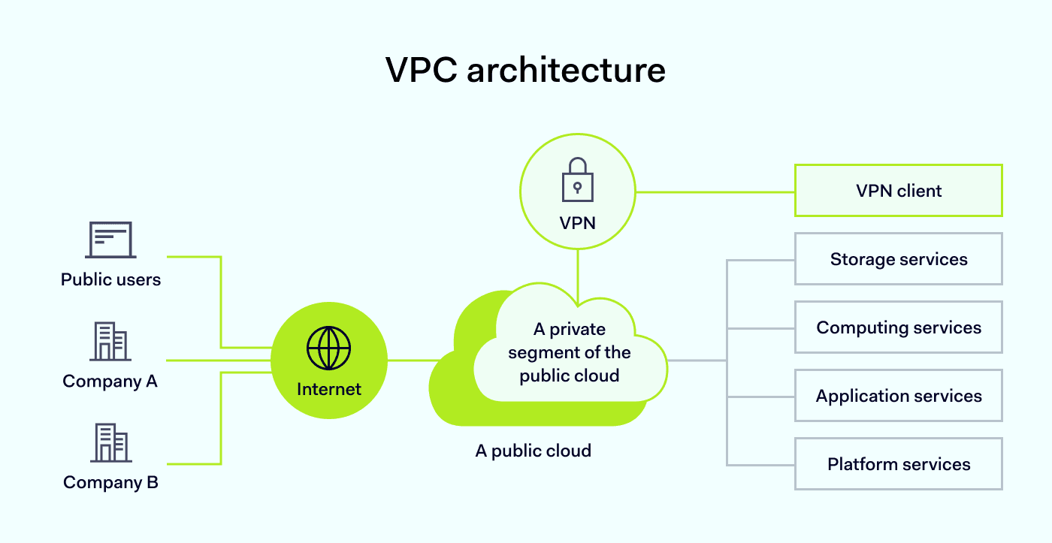

High-Level Workflow
- Client request: User hits your app URL → DNS resolves to ALB public IP in the public subnets.
- Ingress to VPC: Traffic enters via Internet Gateway → routed to ALB in public subnet.
- Load balancing: ALB forwards request to EC2 instances in private subnets (using target groups and security group rules).
- App processing:
  - App servers handle request.
  - If database access needed, traffic flows from app SG to DB SG in database private subnet.
- Outbound calls:
  - If app needs internet (e.g., external API), traffic from private subnet routes to NAT Gateway → Internet Gateway → external service.
  - If app needs AWS services (S3/DynamoDB) privately, traffic uses VPC Endpoints instead of internet.
- Responses:
  - App sends response to ALB → ALB sends response back to client via Internet Gateway.

Pros and Cons
Pros
- Strong isolation and security: Separate IP space, security groups, NACLs, private subnets, endpoints, and logging with VPC Flow Logs.
- High flexibility: Fully customized CIDR, subnet layout, multi-AZ design, and routing (internet, on-prem, multi-VPC).
- Enterprise connectivity: VPN, Direct Connect, Transit Gateway, and peering enable complex hybrid and multi-account topologies.
- Cost and performance control: Private access to AWS services via VPC Endpoints; no need to expose everything to internet.
Cons
- Complexity: Subnets, route tables, gateways, security groups, NACLs, multiple VPCs → steep learning curve and easy to misconfigure.
- Region-bound: Each VPC is tied to a single AWS region; cross-region connectivity needs peering or Transit Gateway and careful design.
- Networking limits and quotas: CIDR overlaps, route limits, and NAT/IGW bandwidth can become constraints in large environments.
- Cost overhead: NAT Gateways, Transit Gateways, data transfer, and endpoints can add significant recurring cost if not designed carefully.

Conclusion
For understanding-level learning and interviews, focus on: what a VPC is, how you design subnets (public vs private), how routing and gateways work, and how security groups/NACLs control traffic. If you can explain the 3-tier architecture text diagram and walk through the end-to-end request flow, your conceptual understanding of AWS VPC is strong.
AWS Compute Services provide a broad set of cloud-based solutions to deploy, run, and scale applications efficiently on Amazon's infrastructure. Here is an in-depth overview:
- Amazon EC2 (Elastic Compute Cloud): Scalable virtual servers that allow you to configure CPU, memory, storage, and networking. You select instance types based on your workload (general purpose, compute, memory-optimized). EC2 supports persistent storage via EBS, security through security groups, and flexible networking in VPCs.
- Amazon ECS (Elastic Container Service) and Amazon EKS (Elastic Kubernetes Service): Container orchestration services for running Docker containers at scale. ECS is AWS's proprietary service, while EKS offers managed Kubernetes clusters, enabling containerized applications' deployment and management.
- AWS Lambda: Serverless computing that runs code in response to events without managing servers. Billing is based on actual compute time, supporting event-driven architectures and microservices.
- AWS Fargate: Compute engine for ECS and EKS that lets you run containers without provisioning or managing servers.
- AWS Elastic Beanstalk: Platform as a Service (PaaS) that handles deployment, capacity provisioning, load balancing, scaling, and health monitoring for applications.
- AWS Batch: Manages and scales batch computing workloads in the cloud.
- Hybrid and Edge Compute:
  - AWS Outposts brings AWS infrastructure and services to on-premises data centers.
  - AWS Wavelength deploys applications near 5G edge devices for low latency.
  - AWS Snow Family devices enable compute and storage in disconnected or rugged environments.
- Compute Optimization and Management Tools:
  - AWS Compute Optimizer recommends optimal instance types to improve cost and performance.
  - AWS Savings Plans provide flexible pricing for compute usage discounts.
These services cover traditional VM-based compute, containers, serverless functions, batch processing, and edge computing. They integrate deeply with networking, storage, security, and monitoring to support a wide variety of workloads, from enterprise applications to IoT and machine learning.
This comprehensive portfolio allows businesses to choose the right compute paradigm for their specific needs with scalability, flexibility, and cost control in mind

